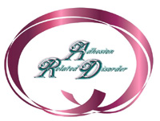
“Unsung Hero in the World of ARD!”

Certificate of Special Recognition

Presented to

Karla Nygren

in recognition of outstanding and invaluable contributions
in education and awareness of
“Adhesion Related Disorder.”

September 5, 2005
Adhesion Related Disorder Awareness Month

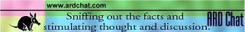
Because Karla takes every opportunity to educate about ARD, she is the first person to be
recognized for her selfless devotion to persons afflicted with
“Adhesion Related Disorder (ARD).”
Karla shares her tragic story with all so others may be spared her fate and in that,
she has made a positive difference in the lives of many.
She is indeed an ARD unsung hero!
God Bless you Karla.

